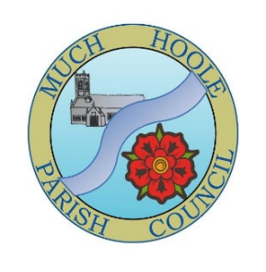
Much Hoole Parish Council
Community Infrastructure Levy Report 2024-2025

Reporting to: 1 April 2024 to 31 March 2025
Completed by: Amy Evans – Clerk to Much Hoole Parish Council

CIL INCOME RECEIVED
Date received | CIL reference | Amount
06/11/2024 | 0000502879  0000502880 | £1,490.26
Total for the year |  | £1,490.26

CIL EXPENDITURE
Date | Description of expenditure | Amount Spent
09/04/2024 | Recreational Infrastructure: Plant hire | £234.00
22/04/2024 | Recreational Infrastructure: Cycle track repair labour | £540.00
22/04/2024 | Recreational Infrastructure: Plant hire | £91.20
23/05/2024 | Community Garden and Green Space Development: Materials for upgrading the community garden at Trafalgar gardens | £265.30
19/06/2024 | Recreational Infrastructure: Cycle track materials (land drain, concrete, fuel for machinery) | £376.40
19/06/2024 | Recreational Infrastructure: Cycle track materials | £150.00
20/06/2024 | Recreational Infrastructure: Cycle track signs | £142.80
01/07/2024 | Recreational Infrastructure: Picnic table | £1,078.80
18/07/2024 | Recreational Infrastructure: Cycle track signs | £113.10
18/10/2024 | Recreational Infrastructure: Cycle track posts | £23.10
13/11/2024 | Infrastructure Upgrades (Footpath Repairs): Instillation of steps at the stile on FP28 | £51.04
18/02/2025 | Community Garden and Green Space Development: Information signs for the fruit trees in the Community Orchard Garden | £288.00
18/02/2025 | Recreational Infrastructure: No Digging Sign for cycle pump track | £123.55
18/02/2025 | Community Garden and Green Space Development: Materials for planting the fruit trees and fir tree at the Community Orchard Garden. | £103.00
18/02/2025 | Public Information and Amenities: PRoW Map for Residents | £360.00
14/03/2025 | Recreational Infrastructure: Cycle track sign materials | £8.58
14/03/2025 | Recreational Infrastructure: Cycle track sign | £85.20
28/03/2025 | Public Information and Amenities: PRoW Map for Residents second and final payment | £360.00
28/03/2025 | Public Information and Amenities: Public Information and Amenities: PRoW Map pamphlets printing cost 1250 copies | £220.00
Total spent by 31/03/2025 |  | £4614.07

CIL RECEIPTS RETAINED AT THE END OF THE REPORTED YEAR 31/03/2025
Year | Amount received | Amount of CIL spent | Amount carried over to following year
2022 | £16,854.48 | £700.40 | £16,154.08
2023 | £6,436.72 | £198.78 | £22,392.02
31/03/2024 |  |  | £17,940.26
2024 | £1,490.26 | £4614.07 | £14,816.45
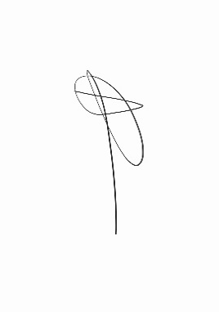

Signed by: Position: Clerk & Responsible Financial Officer

Printed: Miss Amy Evans

